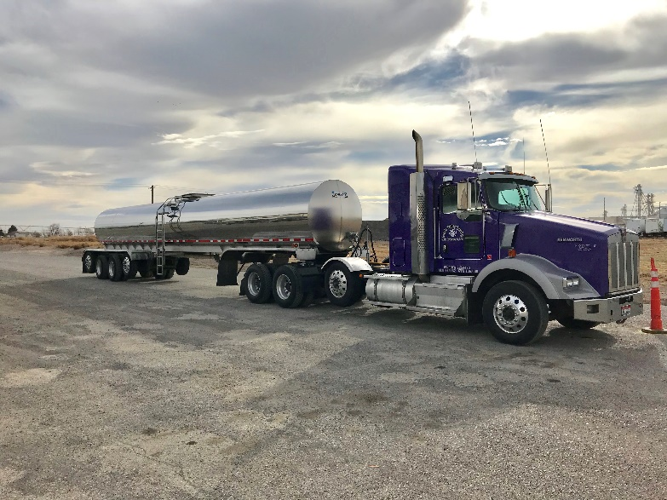

Milk Producers of Idaho

associate Membership Application

Applicant Information
Name:
Company Name | Phone:
Current address:
City: | State: |  | ZIP Code:
Email: | Website:

additional contact names:
Name
Name

membership dues information
Contributions at any level or amounts are welcome.
For our membership with benefits such as recognition on our website as well as newsletters; please refer to the following dues structure.
As an associate member you will be billed once every year-every 12 months from the date that your business joins our organization. Please circle or check the appropriate membership level.
- PLATINUM $5,000/YEAR
- GOLD $2,500/YEAR
- SILVER $1,000/YEAR
- BRONZE $500/YEAR
*Requirements of the Federal Internal Revenue Service (IRS) require that MPI inform members that the portion of association expenses related to direct lobbying efforts are not deductible under federal tax law. MPI has set that percentage at 12%.

Signature: | Date:

